**Project Report  
QUICK KART**OFFLINE TO ONLINE BUSINESS IS OUR PRIORITY

*Submitted in partial fulfilment of the requirement of the degree of*

**BACHELORS OF TECHNOLOGY**

In

Computer Science Engineering

To

**K.R Mangalam University**

*By*

**Vivek Rai (2401010303)**

**Krishika Sinha (2401010113)**

**Diksha Kumari (2401010055)**

**Divyansh Singh (2401010071)**

**Under the supervision of Internal Mentor – Ms. Ruchika Bakhar**



Department of Computer Science and Engineering School of Engineering and Technology

K.R Mangalam University, Gurugram-122001, India

**CERTIFICATE**

This is to certify that the Project Synopsis entitled, “**Quick Kart**” submitted by “**Vivek Rai (2401010303), Krishika Sinha (2401010113), Diksha Kumari (2401010055) and Divyansh Singh (2401010071)”** to **K.R Mangalam University, Gurugram, India,** is a record of bonafide project work carried out by them under my supervision and guidance and is worthy of consideration for the partial fulfilment of the degree of **Bachelor of Technology** in **Computer Science and Engineering** of the University.

**Type of Project: Industry**

Name of Internal supervisor: Ms. Ruchika Bakhar

# INDEX

|  |  |  |
| --- | --- | --- |
| 1. | Abstract |  |
| 2. | Acknowledgement |  |
| 3. | Introduction: Quick Kart |  |
| 4. | Objectives |  |
| 5. | Importance |  |
| 6. | Problem |  |
| 7. | Methodology |  |
| 8. | Outcomes |  |
| 9. | Applications |  |
| 10. | Challenges and Limitation |  |
| 11. | SYSTEM WALKTHROUGH |  |
| 12. | Conclusion |  |
| 13. | Reference |  |

1. **ABSTRACT**

This project focuses on helping **Quick Kart**, a local retail store in Sohna, Haryana, take the next big step—going online. With more people turning to online shopping for convenience, Quick Kart is aiming to reach beyond its physical location and make its products available to customers wherever they are. The goal is simple: make shopping easier and faster for customers, while also growing the business.

To do this, the project outlines how the online platform will work—from browsing products to adding them to the cart, checking out securely, and tracking orders. Features like real-time stock updates, secure payments, and a user-friendly interface are central to the plan. Along the way, the report also looks at potential challenges like handling deliveries, competing with big brands, and earning customer trust in the digital space.

In the end, this move to an online platform is expected to open new opportunities for Quick Kart—leading to more sales, happier customers, and long-term success in a digital world.



# Acknowledgement

I would like to sincerely thank everyone who supported me throughout this project journey.

First, I’m incredibly grateful to my project guide, **[Ms. Ruchika Bakhar]**, for their constant support, valuable advice, and encouragement. Their guidance helped me stay focused and confident, especially when things got challenging.

I also want to thank my teachers and faculty members at **[**K.R Mangalam University**]** for their suggestions and feedback, which really helped me improve my work and learn throughout the process.

A big thank you to my friends and classmates for being there when I needed help or just someone to talk to during the project. Your support made a big difference.

Lastly, I’m deeply thankful to my family for always believing in me and encouraging me, even during the stressful moments. Your love and support kept me going.

This project has been a learning experience, and I truly appreciate everyone who played a part in it.

# INTRODUCTION

# Quick Kart, a local offline store based in Sohna (Haryana), is taking the exciting step to expand its reach by moving online. This transition aims to provide convenience for customers who previously visited the physical store, allowing them to shop from the comfort of their homes. The online platform will feature a wide range of products available at Quick Kart, ensuring customers have access to all the items they love and need.

# 

# OBJECTIVES

* **Expand Customer Reach:** Make Quick Kart’s products accessible to customers beyond Sohna, increasing the customer base.
* **Enhance Convenience:** Provide customers with the ability to shop anytime, anywhere, offering a seamless online shopping experience.
* **Boost Sales & Growth:** Increase revenue by tapping into the growing e-commerce market and scaling operations.
* **Improve Customer Engagement:** Offer personalized services, promotions, and direct communication to strengthen customer relationships



1. **IMPORTANCE**

* **Convenience & Accessibility:** Quick Kart’s online presence allows customers to shop easily from anywhere, anytime, providing greater convenience compared to the offline store.
* **Business Growth:** Going online expands Quick Kart’s reach beyond Sohna, opening doors to new customers and markets, leading to increased sales opportunities.
* **Customer Engagement:** The online platform enables Quick Kart to interact with customers through personalized offers, promotions, and better communication, improving customer satisfaction and loyalty.

1. **PROBLEM**

* Logistics & Delivery: Managing delivery logistics efficiently could be tricky, especially if customer orders grow rapidly. Ensuring timely delivery while maintaining product quality is critical.
* Competition: The online market is competitive, with many established e-commerce platforms. Quick Kart will need to find ways to stand out, whether through pricing, unique products, or exceptional customer service.
* Technical Setup and Maintenance: Establishing and maintaining a functional, secure, and user-friendly website or app can be complex and may require technical expertise.
* Logistics and Delivery Issues: Efficiently managing product inventory, packaging, and timely delivery can become more complicated as the customer base expands beyond local reach.
* **Customer Trust and Security:** Ensuring that customers feel secure shopping online, with safe payment systems and privacy protections, is crucial. Building trust can take time.
* **Increased Competition:** The online market is crowded with many competitors. Quick Kart will need to differentiate itself with unique products, competitive pricing, and exceptional service.
* **Digital Marketing:** Reaching new customers through online marketing (SEO, social media, ads) requires investment in strategies and understanding the digital landscape.
* **Adaptation of Traditional Business Practices:** The shift may require a change in business operations, such as handling customer inquiries online or adapting to new inventory systems, which can take time to master.

1. **METHODOLOGY**
2. **Product Selection**

* **Browse and Search:** Customers can browse categories or search for specific products.
* **Add to Cart:** Once a product is found, users can add it to their shopping cart. This action should display a confirmation message (e.g., "Added to Cart").

**2. after Purchase**

* **Tracking:** Provide order tracking information once the items are shipped.

1. **Cart Management**

* **View Cart:** Users can view the contents of their cart by clicking on the cart icon, which should display the items added, including quantity, size, color, price, and a subtotal.
* **Edit Cart:**
* Change item quantity **(e.g., increase or decrease)**.
* Remove items from the cart.
* Update prices automatically when changes are made.
* **Apply Coupons or Discounts:** Provide an option to enter promo codes or discount coupons before checkout.

**4. Checkout Process**

* **Guest Checkout / Account Login:** Allow customers to either log in or proceed as guests for a quicker checkout.
* **Shipping Information:** Collect shipping details (name, address, phone number, etc.).
* **Shipping Method Selection:** Offer different delivery options. it will say fast or slow delivery.
* **Payment Information:** Provide secure payment gateways like—UPI, COD
* **Order Review:** Display a final order summary (items, shipping details, total price).

**5. Security Features**

* **SSL Encryption:** all personal and payment data is encrypted and not share with anyone.
* **Payment Gateway:** don’t worry us use all Indian trusted payment method.

**6. Additional Features**

* **Wishlist:** Allow users to save items to a wishlist for later purchase.
* **Real-time Stock Updates**: Ensure cart reflects accurate inventory in real-time to avoid overselling.

1. **OUTCOMES**

* Higher conversions and completed purchases.
* Increased sales through upselling and repeat customers.
* Improved user experience with easy navigation and checkout.
* Customer trust through secure payments and clear communication.
* Operational efficiency with streamlined processes.
* Valuable insights for better marketing and inventors.

1. **APPLICATIONS**

* **E-commerce Platforms:** It’s essential for online stores to allow customers to select, manage, and buy products.
* **Subscription Services:** For managing recurring payments or membership sign-ups.
* **Digital Goods:** Used for buying software, e-books, or online courses.
* **Marketplaces:** Multi-seller platforms use it for buyers to add and purchase items from different sellers.
* **Mobile Apps:** Shopping carts are integrated into retail apps for a smooth mobile shopping experience

1. **CHALLENGES AND LIMITATIONS**

* **Security:** Protecting customer data is crucial any breach can harm trust.
* **Tech Glitches:** Bugs like wrong pricing or stock updates can frustrate buyers.
* **Payment Issues**: Not all customers use the same payment methods, which can limit flexibility.
* **Mobile Compatibility:** Ensuring the cart works smoothly on all devices can be tough.
* **Inventory Syncing:** Keeping stock accurate in real-time to avoid overselling is challenging.

1. **SYSTEM WALKTHROUGH:**

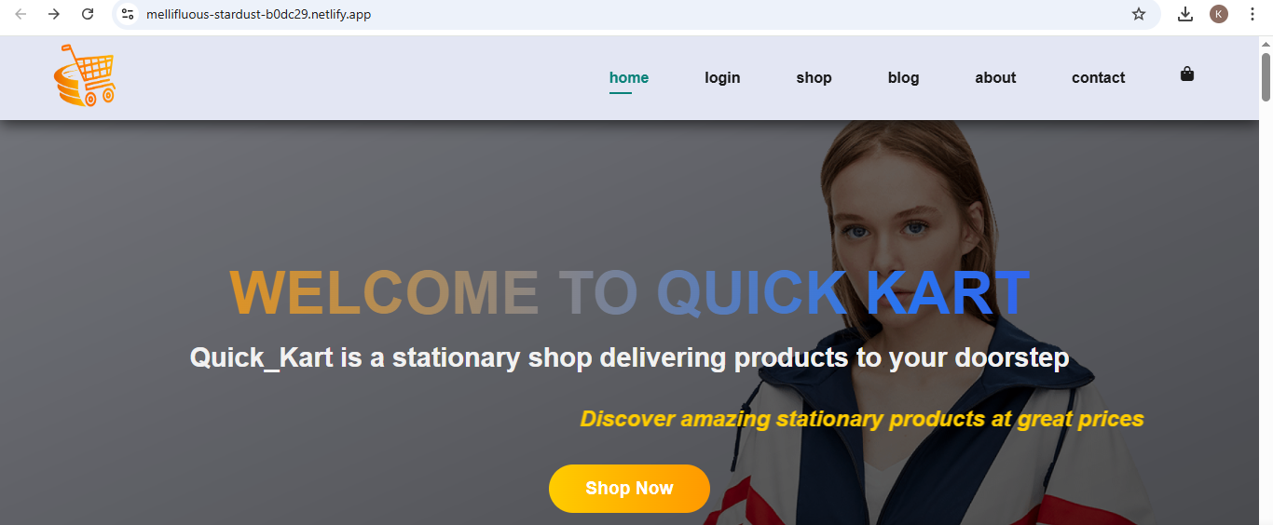

* For each level either its User, Admin or Super Admin there is a login detail page in which the one has to fill the details in terms to access the portal further.

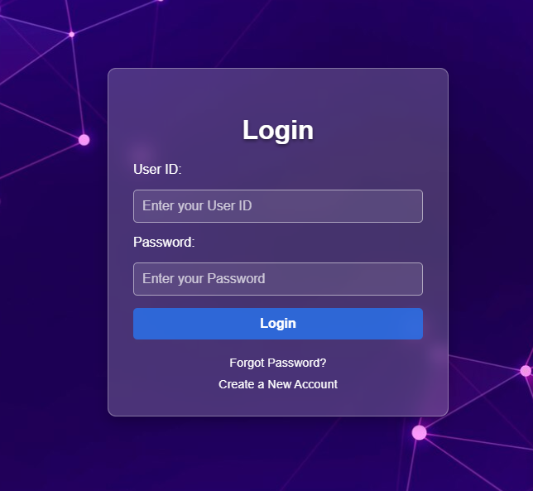

* **Here we can use any category to buy anything.**

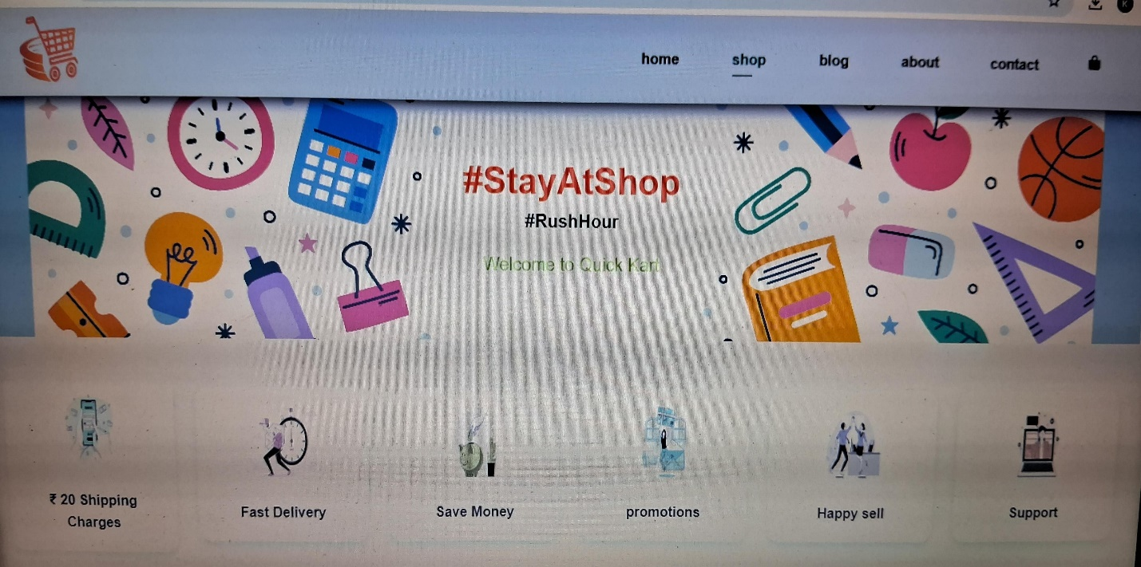

*  Blog is about read more about our products and

Services

* **We will get very cheap and good products to our customers**

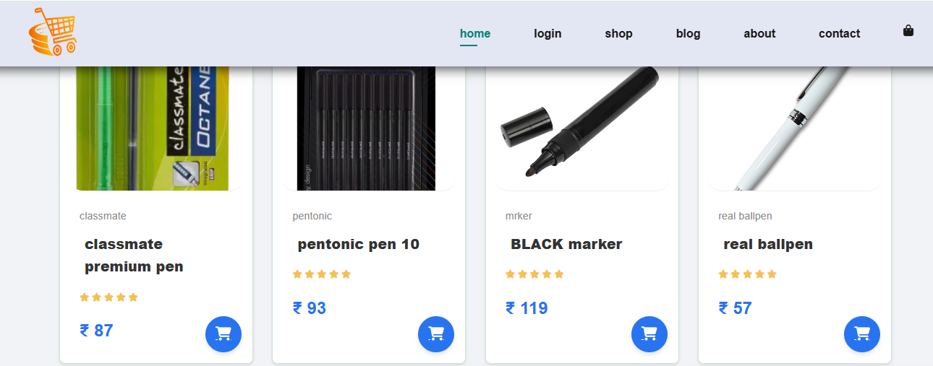

1. **CONCLUSION**

In conclusion, an effective online shopping cart system is key to providing a smooth shopping experience, boosting conversions, and increasing sales. However, challenges like cart abandonment, security risks, and tech issues must be carefully managed. By focusing on simplifying the user experience, offering secure payment options, and optimizing for mobile, businesses can overcome these obstacles. With constant improvements and attention to customer needs, the shopping cart process can drive long-term success and customer loyalty.

1. **REFERENCE**

* **Amazon**: As one of the world’s largest e-commerce platforms, Amazon offers a robust shopping cart system with features like personalized recommendations, seamless checkout, and secure payment options.
* **Flipkart:** A leading Indian e-commerce site, Flipkart’s cart system focuses on easy product management, various payment methods, and fast delivery options, ensuring a smooth shopping experience for its users.